Once you attach an ARM Cortex to your custom IP, it’s time to program the ARM to interface to your IP. The slv_regX that you connected to your custom IP are memory mapped locations. Thus writing to the correct address, will send bits to the input ports of your custom IP entity and reading from another address will read the output from some other port on your custom IP.

Let’s start at the beginning. Launch Xilinx Vitis. Do not launch anything else
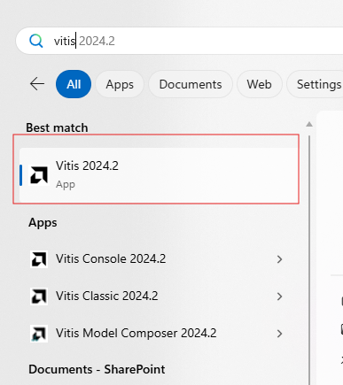

When you launch, point to your workspace by clicking on Set Workspace from the launch page. Vitis does not like long paths nor does it like spaces in the path names. I parked my workspace right off root at c:\my_workspace. You will probably have to create a new folder the first time you do this.

At the Welcome tab, select Create Platform Component from the left menu. This starts the Create Platform Component. The Wizard will walk you through different pages, let’s go through them together.
Name and Location: Provide a useful Component name, maybe something like “enhancedPwm_platform”. Leave Component location alone. Click Next.
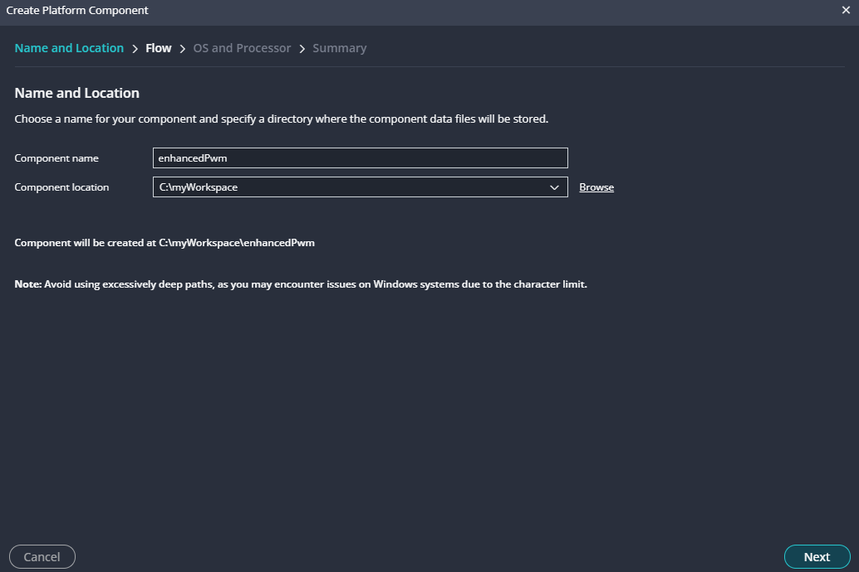

Flow: Click Browse and navigate to your exported XSA file generated by Vivado. In my case, this was at: C:\Users\...\Mycourses\EENG498\VHDL_fall2023\preLab04\ZynqPlusPwm\ZynqWithPwm_wrapper.xsa
and the then click Open. Click Next
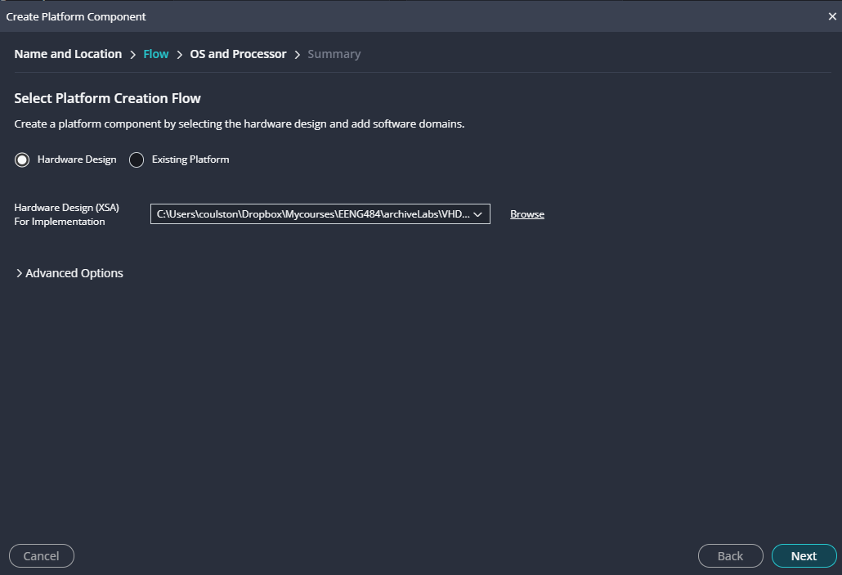

OS and Processor: Be patient as the Wizard needs to unpack your xsa file. Once it does, unselect “Generate Boot artifacts” and then click Next.
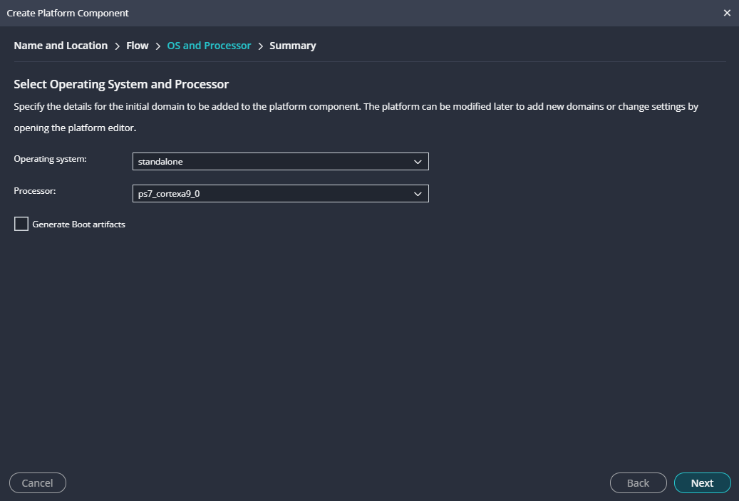
Summary: Recheck your work and then click Next.
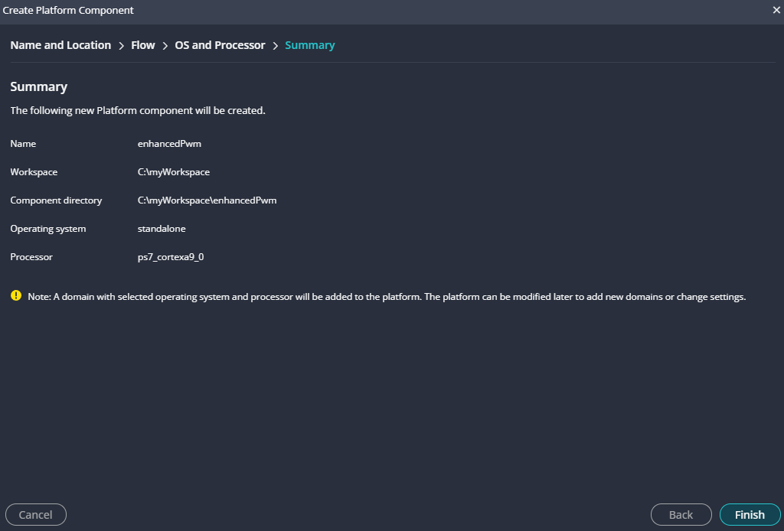

You are at the main development window. Click on Build.
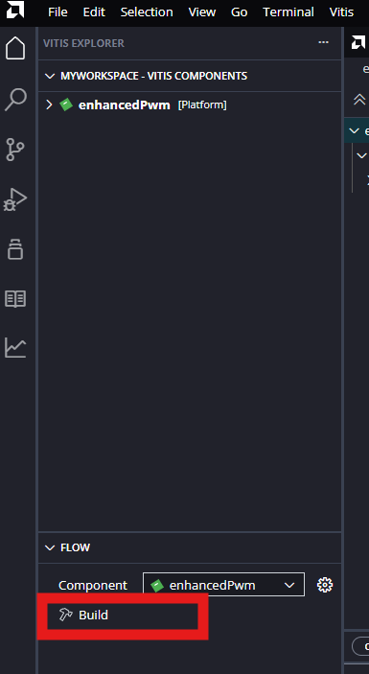

If your build fails for any reason, I would try cleaning the project so that the build starts fresh with the changes that you have made to the makefile and directory structure. The clean tool is the broom that appears when you hover over Build outlined in the previous step.

Create a template application by clicking on the thumb drive icon in the left side bar and then clicking on the plus sign to the right of “Hello World”.
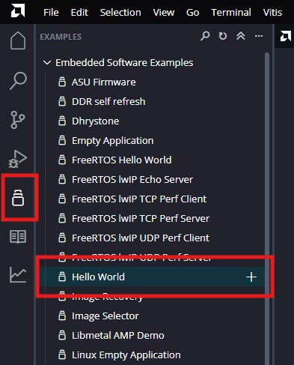

Name and Location: Change the Component name to “enhancedPwm_application”. Leave the Component location alone and click Next.
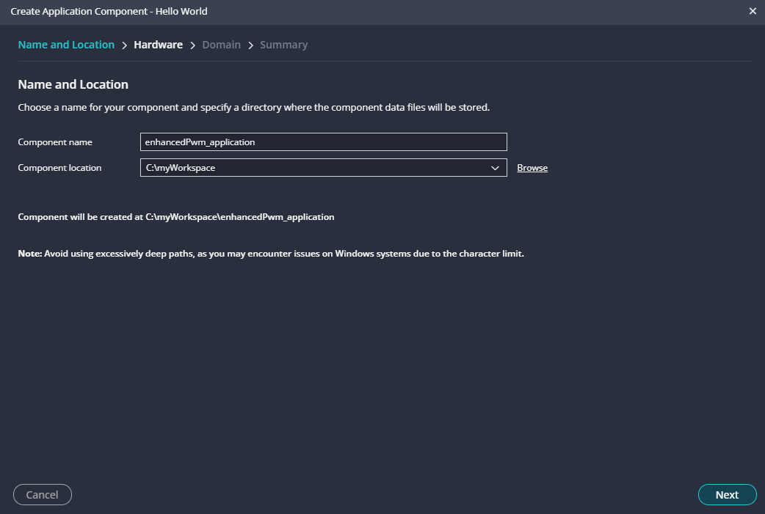

Hardware: Click on the enhancedPwm and then click Next.
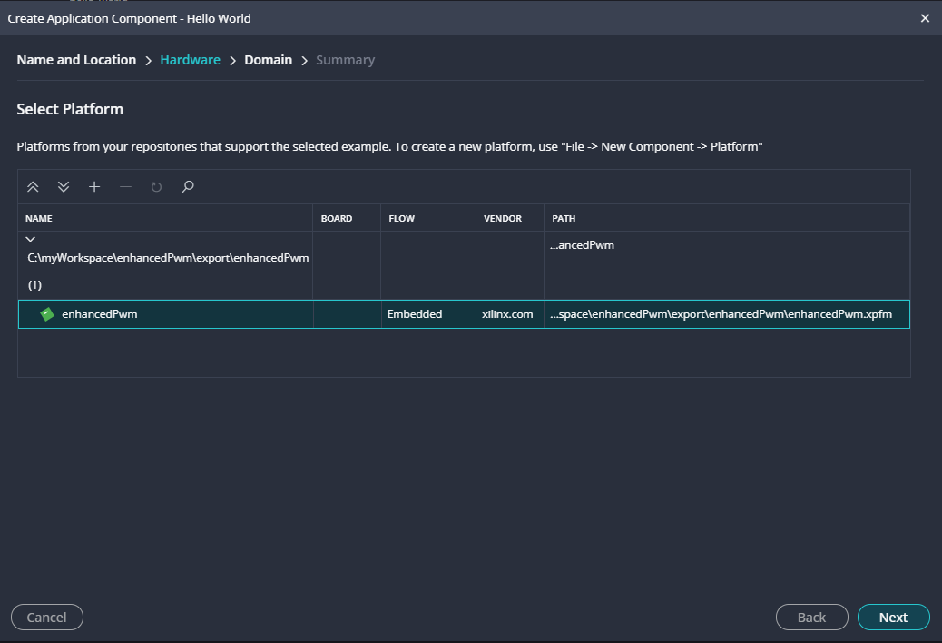

Domain: Just click next
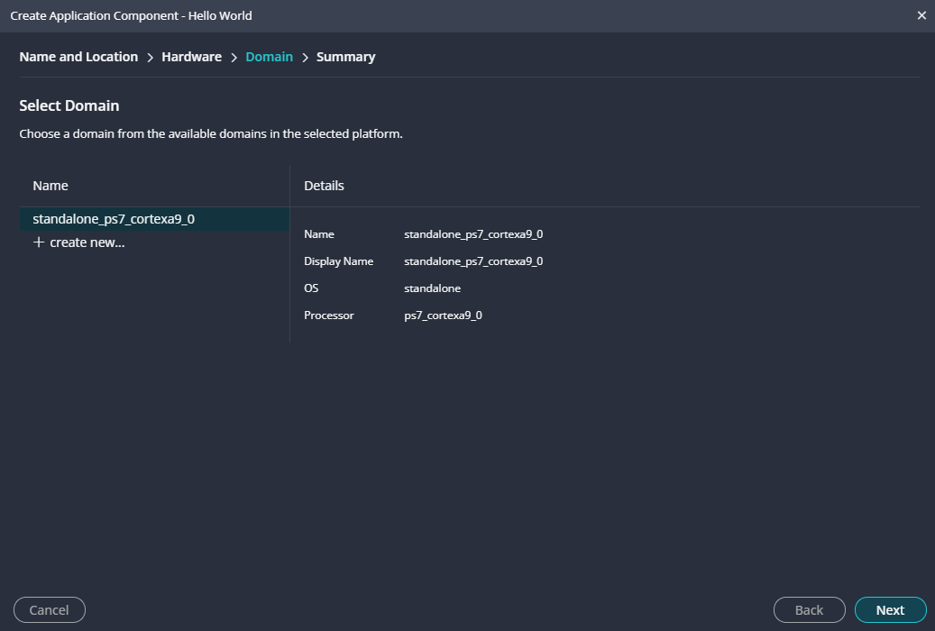

Summary: Check you work and click Finish.
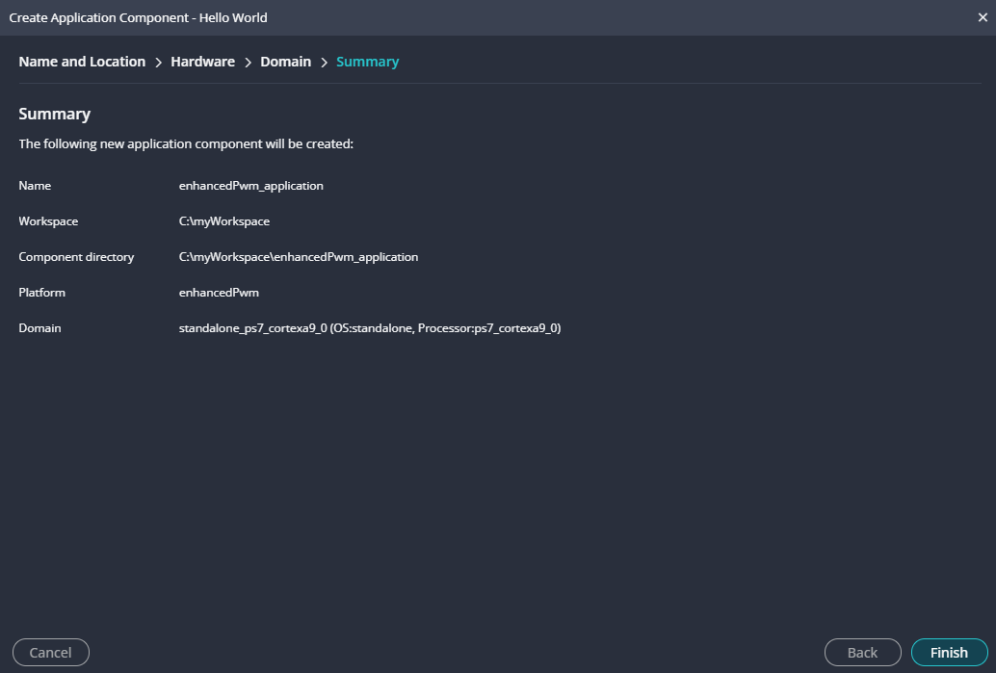

You will be back in the main project window, lets start by opening hellowold.c as shown below.
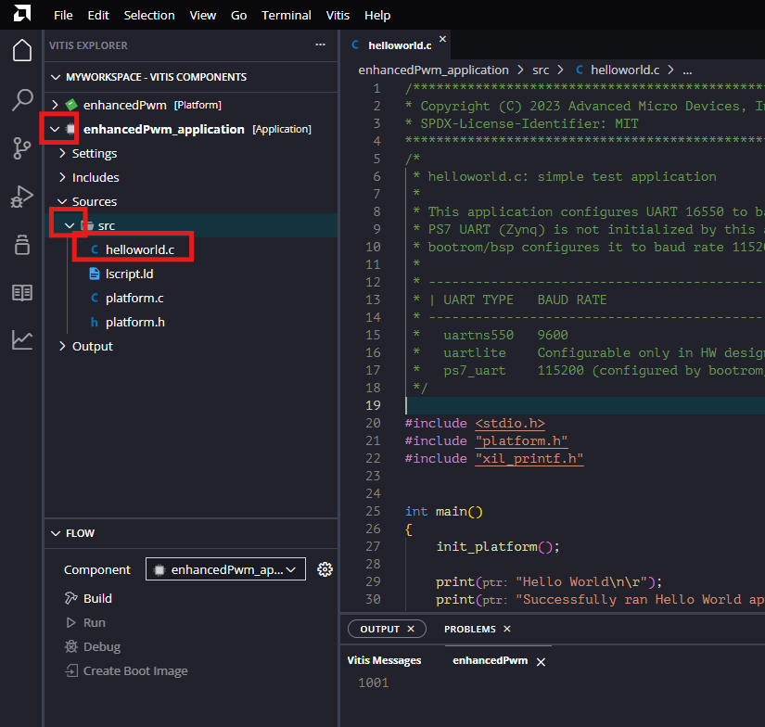
Replace the contents of hellowold.c with the contents of source code provided on my web page.
Then you will need to include enhancedPwm.h and enhancedPwm.c which are the source and header for the IP Core. Do this by right click on src -> import -> Files…
Navigate to
C:\myWorkspace\enhancedPwm\ps7_cortexa9_0\standalone_ps7_cortexa9_0\bsp\hw_artifacts\drivers\enhancedPwm_v1_0\src
And then select both enhancedPwm.c and enhancedPwm.h files
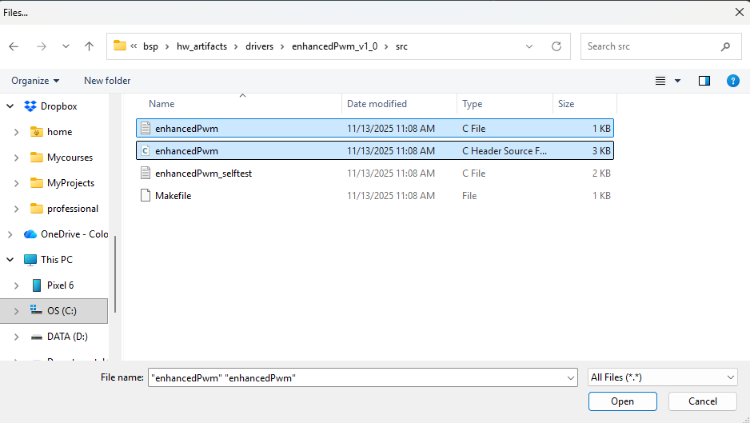

Now click on Build in the Flow window.
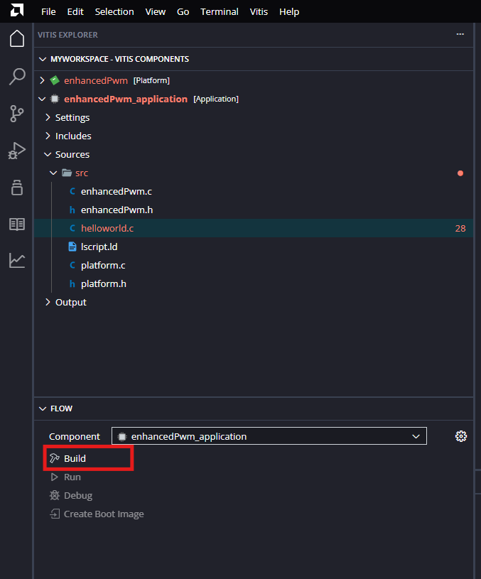
If you see invalid command name “ps7_init” in the lower right corner of the project window you forgot to point the initialization file to
C:\myWorkspace\enhancedPwm_application\_ide\psinit\ps7_init.tcl
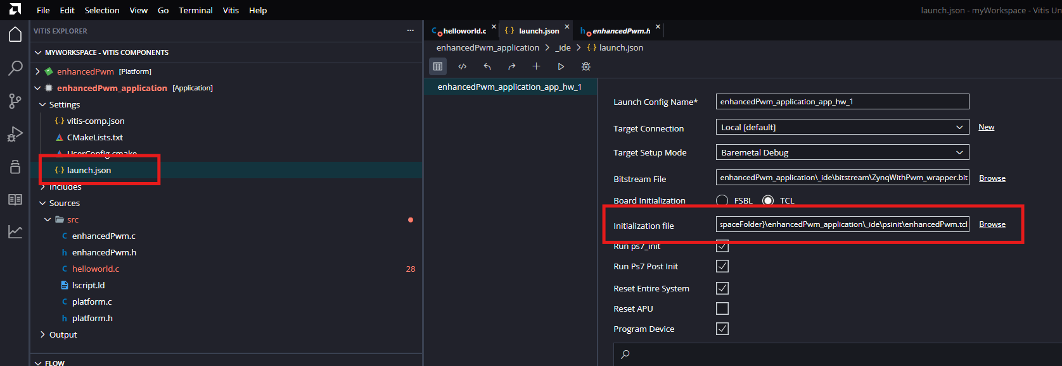

Next click Run to download to the board from the same Flow window. And you’re done!

Browse to C:\myWorkspace\enhancedPwm_application\_ide\psinit select ps7_init and then click Open.
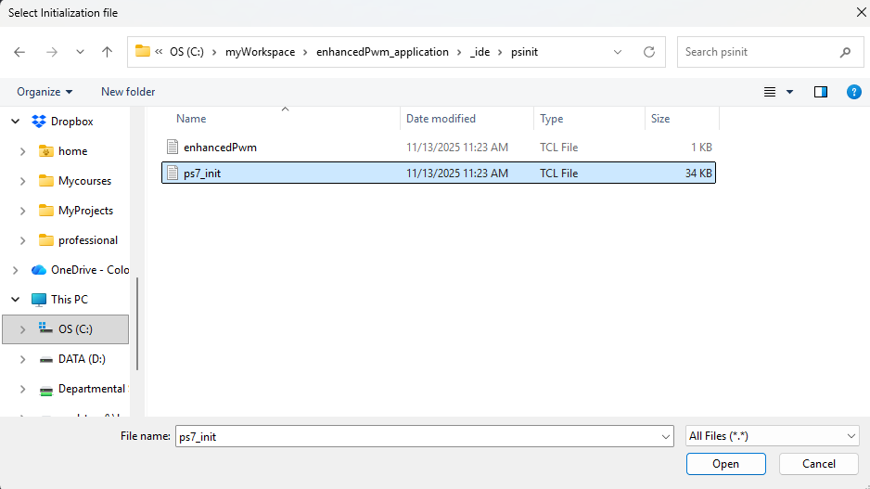

in the Assistant tab, right mouse click on your System name and select Build.

Connect power to the ALINX board as well as the JTAG and UART cables to your PC. Run a jumper from pin 3 of the J11 header to the LPF input.
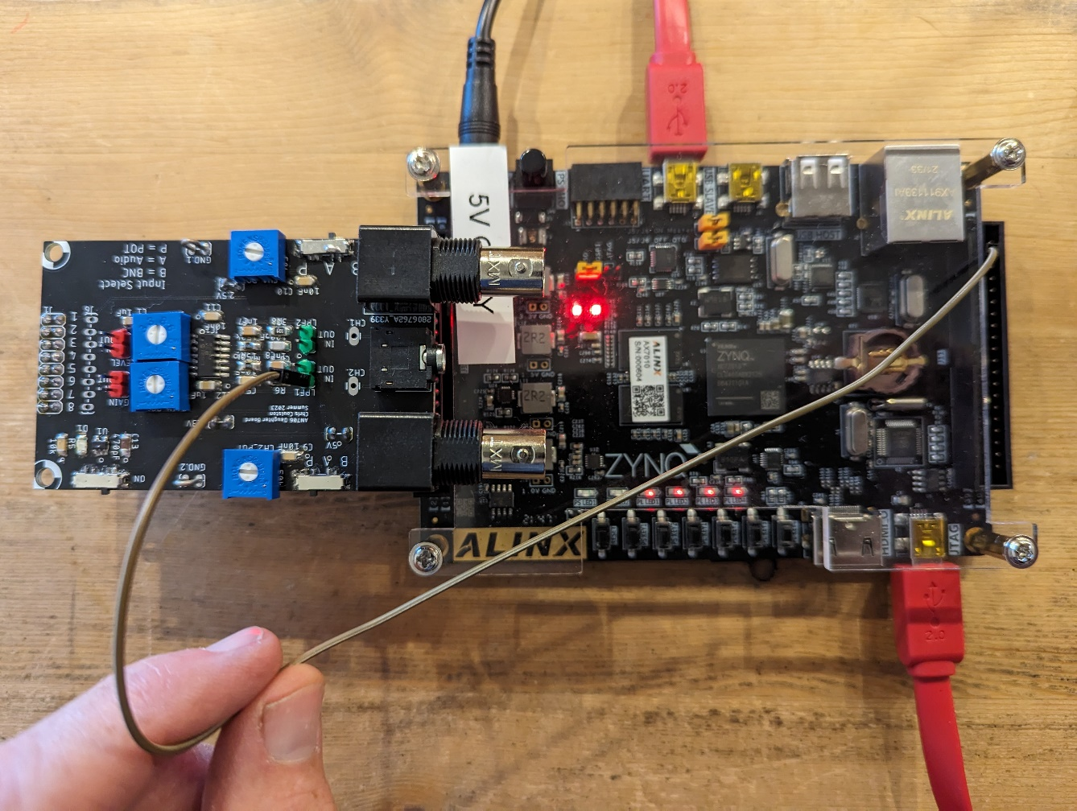

Determine which virtual COM port the ALINX’s board Silicon Lab CP2102 chip is connected to. On a PC, do this by launching the Device Manager.
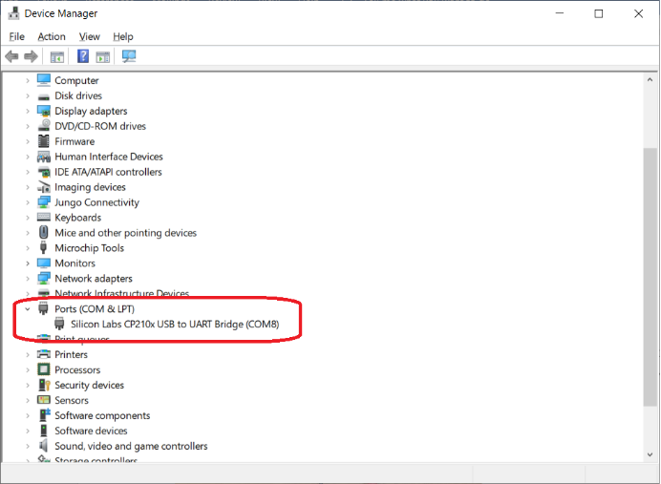
Scroll down the device manager to Ports, expand and look for the Silicon Labs chip. In my case, it is attached to COM8. Now launch Putty, connect to COM8 at 115200 Baud.
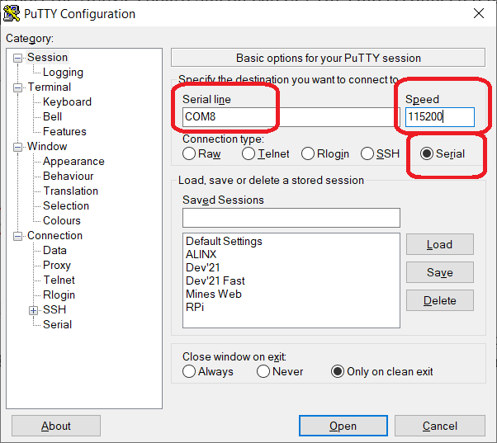

Then download the hardware and software combination to the ALINX board by right mouse clicking on the enhancedPwm [standalone], selecting Run As, then selecting 1 Launch Hardware (Single Application Debug).

<PICTURE TBD>

You can now interact with your custom IP through the Putty interface.
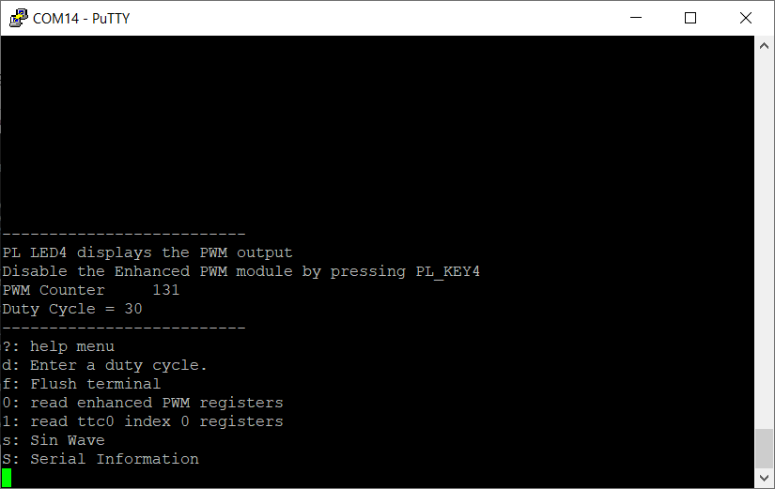

If/when you make changes to your hardware in Vivado, you will need to communicate these changed to Vitis. To do this, just right mouse click on the wrapper and select Update Hardware Specification. In the pop-up, navigate to the updated wrapper file and open it.
<PICTURE TBD>

